[Client Name]
Project Communication Management Plan
[Subtitle as needed]
Primary: [author name], [title]
Month Day, Year

Version History
Version # | Dated | Author
1.1 | 09/28/2015 | B. Cortis

Table of Contents
I. Communication Management Overview 2
II. Plan Communications 3
Delineation of Project Communications Plan 3
Roles & Responsibilities 3
Project Distribution 3
Project Management Information System 3
Schedule Management 4
Budget Management 4
Scope Management 4
III. Manage Communications 5
A. Communication Schedule 5
Communication Element Definition 5
IV. Control Communications 7
A. Communication Practices 7
B. Communication Workflow 7
Scheduled / Distribution (non-board/executive/all) 7
Scheduled / Distribution (board/executive/all) 7
V. Appendix 8

Communication Management Overview
A Project Team’s ability to provide clear, consistent and timeline information is a critical factor in project success. Effective communication management ensures decision-makers have the right information to inform their decisions, aligns stakeholder expectations and elevates risks or issues as needed. Effective communication also celebrates success, notifies resources of upcoming activity and generally ensures that stakeholders know where the project stands.
The Communication Management Plan is intended to provide processes that will ensure timely and appropriate communication to project stakeholders. This document adheres to the Project Management Institute’s definition of Communication Management:
Project Communications Management includes the processes that are required to ensure timely and appropriate generation, collection, distribution, storage, retrieval, and ultimate disposition of project information.
Project Management Book of Knowledge (PMBOK), V5 2013
The Project Management Institute (PMI) describes three processes to support effective Communication Management. They are as follows:

The Communications Management Plan will formalize the approach to applying these processes to this project. The Communications Management Plan will also document a Communications Schedule, workflow and other tools that will support project communications.

Plan Communications
The following section will describe communication roles and responsibilities and distribution lists to be created and used throughout the project. A Project Management Information System will also be identified and usage defined for managing project artifacts as well as management of schedule, budget and scope.

Delineation of Project Communications Plan
This plan covers all planned communications in and around the project outside of meetings or discreet communications concerned with execution of the project. For example, regular status meetings are included in this plan, but meetings concerned with requirements gathering are not. A Stakeholder Management Plan will evaluate how communications and implementation approach combine to engage stakeholders and facilitate adoption of project outcomes.

Roles & Responsibilities
- Project Manager will be responsible for Communication Management on the project, including:
  - Ensuring all scheduled communications are sent
  - Providing ad hoc communications as needed
  - Ensuring Project Management Information System (PMIS) reflects all project collateral
- Project Sponsor is responsible for content and message of all Executive Communications and all communications sent for general (all stakeholder) distribution

Project Distribution
The following distribution lists will be created:
Name | Distribution | Owner
#Project | Project Team + Vendor Project Team | Project Manager
#Advisory | Advisory Committee members | Project Lead
#Steering | Steering Committee members | Project Sponsor
#Executive | Executive Committee members | Project Sponsor
#Board | Board members (or sub-committee on board) | Executive Sponsor
#All-stakeholders | All stakeholders of project | Project Sponsor
#External-vendors | All vendors peripheral to project | Project Manager
#All-external | All external stakeholders of project | Project Manager

Project Management Information System
[PMIS-NAME] is the designated Project Management Information System. The following rules govern the PMIS:
- All Project Management Plan related documents will be accessible in the PMIS
- All documents (ex. Minutes, deliverables, templates, other artifacts) will be stored in PMIS
  - IF a document does not exist in the PMIS it does not exist to the project
- All documents should use version control features, maintaining a single, current document with retraceable modifications
- All document changes or additions will notify Project Team daily
- All document changes or additions will be summarized for Project Team weekly

Schedule Management
[Describe how it will be managed in the PMIS]

Budget Management
[Describe how it will be managed in the PMIS]

Scope Management
[Describe how it will be managed in the PMIS]

Manage Communications

Communication Schedule
Project communications are segmented into three categories:
- Project & Governance: Communications in this segment are high in frequency in focused on managing the project. Information is regularly surfaced to governance committees (advisory, steering, executive). And, periodically communications will step back and evaluate project status overall to ensure broader alignment with project objectives.
- Stakeholders: Communications to stakeholders will broadcast project status and help facilitate understanding and acceptance of project outcomes.
- External: Outside of the organization there are external parties that will be impacted by the project. While these parties are inactive on the project they have an interest in the project and late in the project will need to modify their processes or practices. These communications will provide sufficient notice to ensure those vendors are neither surprised nor anxious about embracing project objectives. (note: if a vendor is immediately impacted by the project they should be integrated into Project & Governance communication strategies)
The following Communications Schedule organizes these categories, communication elements and frequency:
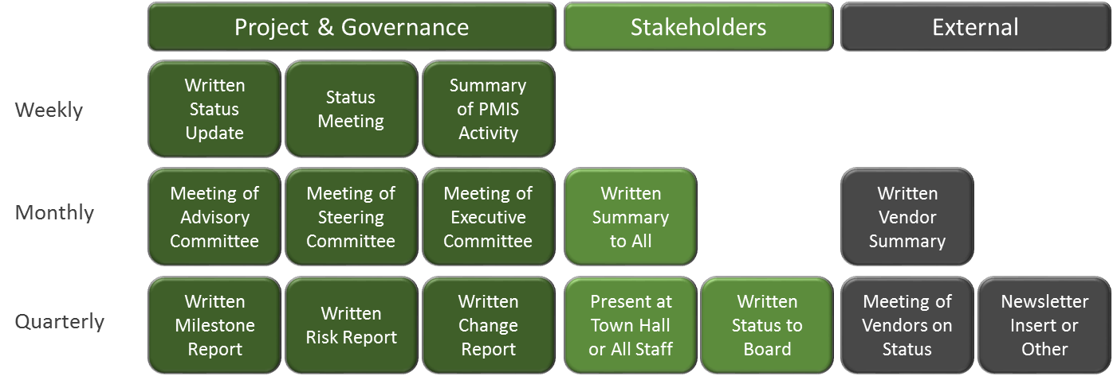

Communication Element Definition
Each communication element is assigned an owner, is delivered with a consistent frequency and has a previously identified distribution list.
Strategy | Owner | Frequency | Distribution
Written Status Update | Project Manager | Weekly | #Project, #Advisory
Status Meeting | Project Manager | Weekly | #Project
Summary of PMIS Activity | PMIS-Generated | Daily | #Project
Summary of PMIS Activity | PMIS-Generated | Weekly | #Project
Meeting: Advisory Committee | Project Lead | Monthly | #Advisory
Meeting: Steering Committee | Project Sponsor | Monthly | #Steering
Meeting: Executive Committee | Project Sponsor | Monthly | #Executive
Written Milestone Report | Project Manager | Quarterly /@ milestone | #Project, #Advisory, #Steering, #Executive
Written Risk Report | Project Manager | Quarterly | #Project, #Advisory, #Steering, #Executive
Written Change Report | Project Manager | Quarterly | #Project, #Advisory, #Steering, #Executive
Written Summary | Sponsor | Monthly | #All-stakeholders
Town Hall/All Staff Presentation | Executive Sponsor | Quarterly | #All-stakeholders
Written Status to Board | Executive Sponsor | Quarterly | #Project, #Executive, #Board
Written Vendor Summary | Project Lead | Monthly | #Project, #External-Vendors
Meeting: Vendors | Project Lead | Quarterly | #Project, #External-Vendors
Newsletter or Other | Project Manager | Quarterly | #All-External

Control Communications

Communication Practices
The following communication practices will help ensure effective project communication:
- All Project Communications will CC the Project Manager
- All Project Collateral will be stored in the PMIS
- All Meetings will have an assigned minute-taker
  - All Minutes will be added to the PMIS
  - All Minutes will follow the Meeting Minute Template

Communication Workflow
All project communications need to be both accurate and timely. The following Communication Workflows describe the process for sending communications.

Scheduled / Distribution (non-board/executive/all)
Non-board/executive/all distributions will be drafted by an author and reviewed and sent by the Project Manager.
PM to Send
Message Author

Scheduled / Distribution (board/executive/all)
Board/executive/all distributions will be drafted by an author and reviewed by the Project Manager and Sponsor. It will then be reviewed and sent by the Executive Sponsor.
Exec. Sponsor to Send
Sponsor to Review
PM to Review
Message Author

Appendix
The following templates should be used throughout this project to deliver communications:
- Weekly Status Update
- Meeting Agenda Template
- Meeting Minutes Template

Craftsman Technology Group, LLC
This information was originally prepared by Craftsman Technology Group, LLC. Craftsman Technology Group LLC
asks that this document not be shared with external parties or posted to public forums.

